LZZBJ9-10电流互感器(A,B,C)

一、产品概述
LZZBJ9-10电流互感器是户内环氧树脂浇注支柱式全工况型产品，在额定频率50Hz、额定电压10kV及以下的电力系统作电流、电能计量或继电保护使用,适用于中置式开关柜及其它型式的开关柜，本型号的产品还可根据用户要求生产二、三绕组复变比结构。
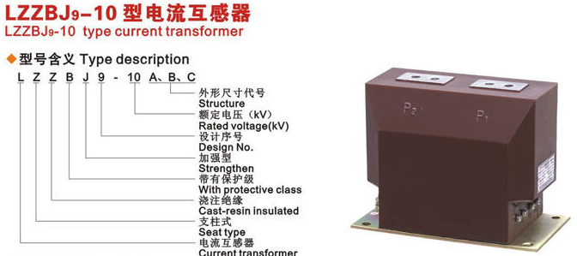

二、电流互感器结构及特点
LZZBJ9-10(A,B,C)型电流互感器由于采用了环氧树脂全封闭浇注所以产品耐潮湿、耐污秽、尺寸小、重量轻，适合于任何位置、任意方向安装。

三、产品技术参数
1、LZZBJ9-10额定绝缘水平：12/42/75kV ；
2、负荷的功率因数：COSφ=0.8（滞后）；
3、 额定二次电流：5A或1A;
4、表面爬电距离：满足II级污秽等级要求；
5 、产品标准：GB1208-2006《电流互感器》。
6 、仪表保安系数：FS≤10;
7、 其它技术参数见表

四、LZZBJ9-10(A,B,C)型电流互感器技术参数
LZZBJ9-10变比(A) | 准确级组合 | 容量输出(VA) | 短时热电流(KA/S) | 额定动稳定电流(KA/S)
5~15/5A  20~75/5A  100/5A  150~200/5A  300/5A  400~500/5A | 0.2S/10P10 | 10/15 | 100I1n  150I1n  21  31.5  45  63 | 250I1n  375I1n  52.580  52.5  112.5  130
5~15/5A  20~75/5A  100/5A  150~200/5A  300/5A  400~500/5A | 0.5/10P10 | 10/15 | 100I1n  150I1n  21  31.5  45  63 | 250I1n  375I1n  52.580  52.5  112.5  130
5~15/5A  20~75/5A  100/5A  150~200/5A  300/5A  400~500/5A | 0.2S/10P15 | 10/15 | 100I1n  150I1n  21  31.5  45  63 | 250I1n  375I1n  52.580  52.5  112.5  130
5~15/5A  20~75/5A  100/5A  150~200/5A  300/5A  400~500/5A | 0.5/10P15 | 15/15 | 100I1n  150I1n  21  31.5  45  63 | 250I1n  375I1n  52.580  52.5  112.5  130
5~15/5A  20~75/5A  100/5A  150~200/5A  300/5A  400~500/5A | 0.2S/0.5/10P10 | 10/15/15 | 100I1n  150I1n  21  31.5  45  63 | 250I1n  375I1n  52.580  52.5  112.5  130
5~15/5A  20~75/5A  100/5A  150~200/5A  300/5A  400~500/5A | 0.5/0.5/10P10 | 20/20/10 | 100I1n  150I1n  21  31.5  45  63 | 250I1n  375I1n  52.580  52.5  112.5  130
5~15/5A  20~75/5A  100/5A  150~200/5A  300/5A  400~500/5A | 0.5/10P10/10P10 | 20/10/10 | 100I1n  150I1n  21  31.5  45  63 | 250I1n  375I1n  52.580  52.5  112.5  130
400/5A | 0.2S/0.5 | 10/20 | 63 | 130
500/5A | 0.2S/0.5 | 10/15 | 63 | 130
600/5A | 0.2S/0.5 | 10/20 | 63 | 130
600/5A | 0.2S/10P10 | 10/15 | 63 | 130
600/5A | 0.2S/10P15 | 10/15 | 63 | 130
600/5A | 0.2S/10P20 | 10/15 | 63 | 130
600/5A | 0.5/10P10 | 10/15 | 63 | 130
600/5A | 0.5/10P15 | 20/15 | 63 | 130
600/5A | 0.5/10P20 | 20/15 | 63 | 130
600/5A | 0.2S/0.5/10P10 | 10/15/15 | 63 | 130
600/5A | 0.5/0.5/10P10 | 20/20/10 | 63 | 130
600/5A | 0.5/10P10/10P10 | 20/10/10 | 63 | 130
800/5A | 0.2S/10P10 | 10/15 | 80 | 160
800/5A | 0.2S/10P15 | 10/15 | 80 | 160
800/5A | 0.2S/10P20 | 10/15 | 80 | 160
800/5A | 0.5/10P10 | 10/15 | 80 | 160
800/5A | 0.5/10P15 | 20/15 | 80 | 160
800/5A | 0.5/10P20 | 20/15 | 80 | 160
800/5A | 0.2S/0.5/10P10 | 10/10/15 | 80 | 160
800/5A | 0.2S/0.5/10P10 | 10/20/20 | 80 | 160
800/5A | 0.2S/0.5/10P15 | 10/20/15 | 80 | 160
800/5A | 0.2S/0.5/10P20 | 10/20/15 | 80 | 160
800/5A | 0.5/10P10/10P10 | 20/20/20 | 80 | 160
1000/5A | 0.2S/10P10 | 10/15 | 80 | 160
1000/5A | 0.2S/10P15 | 10/15 | 80 | 160
1000/5A | 0.2/10P10 | 10/15 | 80 | 160
1000/5A | 0.2/10P15 | 15/15 | 80 | 160
1000/5A | 0.2/10P20 | 15/15 | 80 | 160
1000/5A | 0.5/10P10 | 10/15 | 80 | 160
1000/5A | 0.5/10P15 | 20/15 | 80 | 160
1000/5A | 0.5/10P20 | 20/15 | 80 | 160
1000/5A | 0.2S/0.5/10P10 | 10/20/15 | 80 | 160
1000/5A | 0.2/0.5/10P10 | 10/20/15 | 80 | 160
1000/5A | 0.2/0.5/10P15 | 10/20/15 | 80 | 160
1000/5A | 0.2/0.5/10P20 | 10/20/15 | 80 | 160
1000/5A | 0.5/10P10/10P10 | 20/20/20 | 80 | 160
1200/5A | 0.2S/10P10 | 15/15 | 100 | 160
1200/5A | 0.2S/10P15 | 15/15 | 100 | 160
1200/5A | 0.2/10P10 | 15/15 | 100 | 160
1200/5A | 0.2/10P15 | 15/15 | 100 | 160
1200/5A | 0.2/10P20 | 15/15 | 100 | 160
1200/5A | 0.5/10P10 | 15/15 | 100 | 160
1200/5A | 0.5/10P15 | 30/15 | 100 | 160
1200/5A | 0.5/10P20 | 30/15 | 100 | 160
1200/5A | 0.2S/0.5/10P10 | 15/15/15 | 100 | 160
1200/5A | 0.2/0.5/10P10 | 15/15/15 | 100 | 160
1200/5A | 0.2/0.5/10P15 | 15/15/15 | 100 | 160
1200/5A | 0.2/0.5/10P20 | 15/15/15 | 100 | 160
1200/5A | 0.5/10P10/10P10 | 30/20/20 | 100 | 160
1500/5A | 0.2S/10P10 | 10/15 | 100 | 160
1500/5A | 0.2S/10P15 | 20/15 | 100 | 160
1500/5A | 0.2S/10P20 | 20/15 | 100 | 160
1500/5A | 0.5/10P10 | 15/15 | 100 | 160
1500/5A | 0.5/10P15 | 30/15 | 100 | 160
1500/5A | 0.5/10P20 | 30/15 | 100 | 160
1500/5A | 0.2S/0.5/10P10 | 10/15/15 | 100 | 160
1500/5A | 0.2S/0.5/10P15 | 10/15/15 | 100 | 160
1500/5A | 0.2S/0.5/10P20 | 10/15/15 | 100 | 160
1500/5A | 0.5/10P10/10P10 | 30/20/20 | 100 | 160
2000/5A | 0.2S/10P10 | 10/15 | 100 | 160
2000/5A | 0.2S/10P15 | 15/15 | 100 | 160
2000/5A | 0.2S/10P20 | 15/15 | 100 | 160
2000/5A | 0.5/10P10 | 30/15 | 100 | 160
2000/5A | 0.5/10P15 | 30/15 | 100 | 160
2000/5A | 0.5/10P20 | 30/15 | 100 | 160
2000/5A | 0.2S/0.5/10P10 | 10/30/15 | 100 | 160
2000/5A | 0.2S/0.5/10P15 | 10/30/15 | 100 | 160
2000/5A | 0.5/10P10/10P10 | 30/20/20 | 100 | 160
2500/5A | 0.2S/10P10 | 15/20 | 100 | 160
2500/5A | 0.2S/10P15 | 15/15 | 100 | 160
2500/5A | 0.2S/10P20 | 15/15 | 100 | 160
2500/5A | 0.5/10P10 | 60/20 | 100 | 160
2500/5A | 0.5/10P15 | 60/15 | 100 | 160
2500/5A | 0.5/10P20 | 60/15 | 100 | 160
2500/5A | 10P10/10P10 | 20/20 | 100 | 160
2500/5A | 0.2S/0.5/10P10 | 15/60/20 | 100 | 160
2500/5A | 0.2S/0.5/10P15 | 15/60/15 | 100 | 160
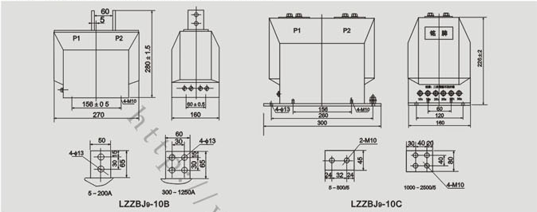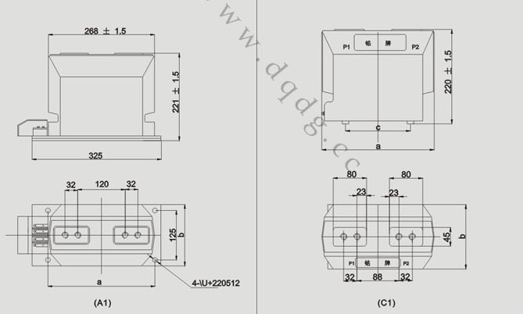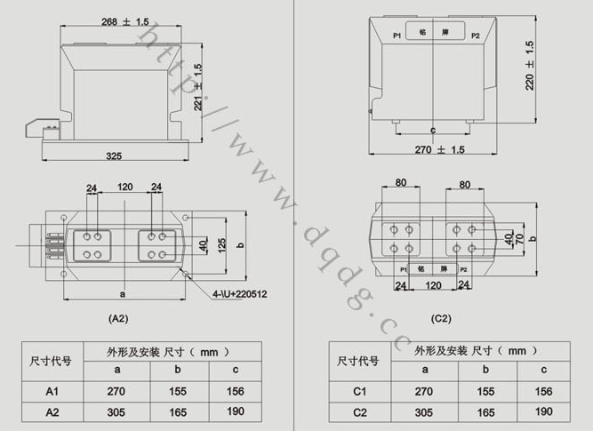
本文地址：http://www.dqdg.cc/LZZBJ9-10-209.html

